Spiritual Gifts and the GREATEST Gift!

1 Cor. 14-15

*“Love is that thing which, if a church has it, it doesn’t really need much else, and if it doesn’t have it, whatever else it has doesn’t really matter very much”.* Haddon Robinson

**Spiritual gifts** **are to be used to promote order, peace, and ______ among God’s people**.

14:1

**Prophecy**/prophet: a messenger of God, revealing God’s message, to the people of God, for their spiritual formation

14: 2-4

**Correcting the wrong understanding/use of gifts**

**1. Gifts are used to build the _______ up** 1 Cor 12:7, 14:12

the common good, not personal gain

**2. Gifts are not marks of spiritual _________**

*1 Cor 14: 20Dear brothers and sisters, don’t be childish in your understanding of these things. Be innocent as babies when it comes to evil, but be mature in understanding matters of this kind.*

**3. Nothing should hurt or hinder the _________ before unbelievers** v16, 23

**4. _________ is our highest goal v. 1**

**5. Church ________ restrains self-centeredness**

*33For God is not a God of disorder but of peace, as in all the meetings of God’s holy people.*

*40But be sure that everything is done properly and in order.*

1 Cor 15:1-11

**What is this Good News? Gospel?**

**1. It is Based on the ________- God’s Word** v. 3

Romans 10:17 So faith comes from hearing, and hearing through the **word** of Christ.

**2. _______ in my place**:

as my substitute, taking the punishment I deserved for my sins

v. 3 Christ died for our sins, buried, and rose on the third day

**Jesus saves sinners** [**Acts 4:12**](http://www.crossbooks.com/verse.asp?ref=Ac+4%3A12) Salvation is found in no one else, for there is no other name under heaven given to men by which we must be saved."

**We are Saved by God’s Grace** and through faith (Eph 2:8,9).

Titus 2:11For the grace of God has appeared that offers salvation to all people.

**My Part: ________**

Faith/trust/belief in Jesus is not just belief **that** Jesus died and rose again, but belief **in**: for the forgiveness of MY sins and Leadership of MY life (Saviour and Lord)

**_________: we are sinners (repent)**

*Apart from repentance, there is no salvation.*

**_________: Jesus died for you and rose again**

**Romans 10:9**  If you confess with your mouth that Jesus is Lord and believe in your heart that God raised him from the dead, you will be saved.

**__________ your life to Follow Him**

1 John 2:3 We know that we have come to know him if **we keep his commands**. 4Whoever says, “I know him,” but **does not do what he commands** is a liar, and the truth is not in that person. 5But if anyone **obeys** his word, love for Godis truly made complete in them. This is how we know we are in him: 6Whoever claims to live in him must **live as Jesus did**.

**Caution: not everyone who *thinks* they are saved, necessarily are.**

Jesus said, Matt. 7:21**"Not everyone who says to me, 'Lord, Lord,' will enter the kingdom of heaven**

**Salvation *may* begin** with praying a prayer but just because one prayed a prayer once, doesn’t necessarily mean they are saved.

It’s the **faith** **relationship** that saves, not the prayer

1 Cor 15:2 It is this Good News that saves you **if you continue to believe** the message I told you

The mark, however, of someone who is saved is that **they maintain** their confession of faith until the end of their lives.

*Salvation is not a prayer you pray in a one time ceremony and then move on from; salvation is a posture of repentance and faith that you begin in a moment, and maintain for the rest of your life.*

*--J.D. Greear Stop asking Jesus into your heart.*

**Am I resting totally on Jesus for salvation**

**…how am I showing it?**

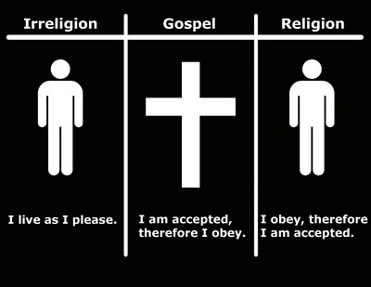

Spiritual Gifts

and the

GREATEST Gift!

1 Cor. 14-15